Test Case: tc001_SPX_Dev5_Crear_Requisicion_Spot_Tipo_Cobro_CC
Step 1 - Enter username and password and click to button Enter : Credentials Entered
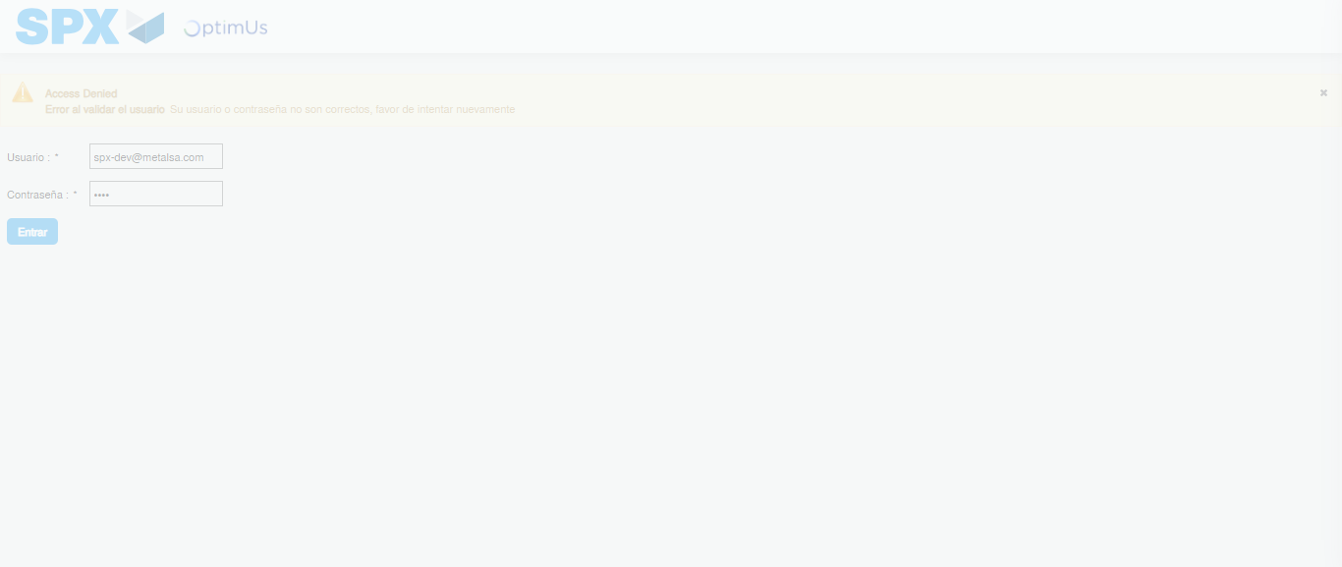Image file-name: QC_Testing-tc001_SPX_Dev5_Crear_Requisicion_Spot_Tipo_Cobro_CC-1783980153039

Step 2 - Select to UEN and Access to Spot Buy Requisitions : UEN Correctly selected and Correct access
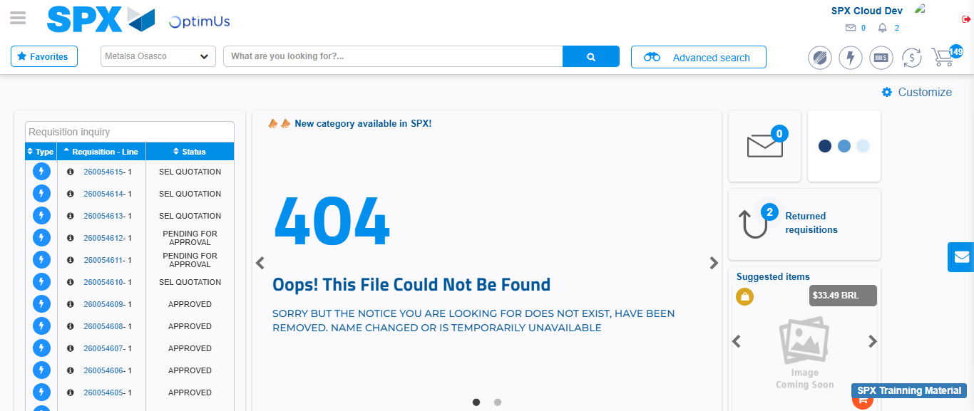Image file-name: QC_Testing-tc001_SPX_Dev5_Crear_Requisicion_Spot_Tipo_Cobro_CC-1783980179077

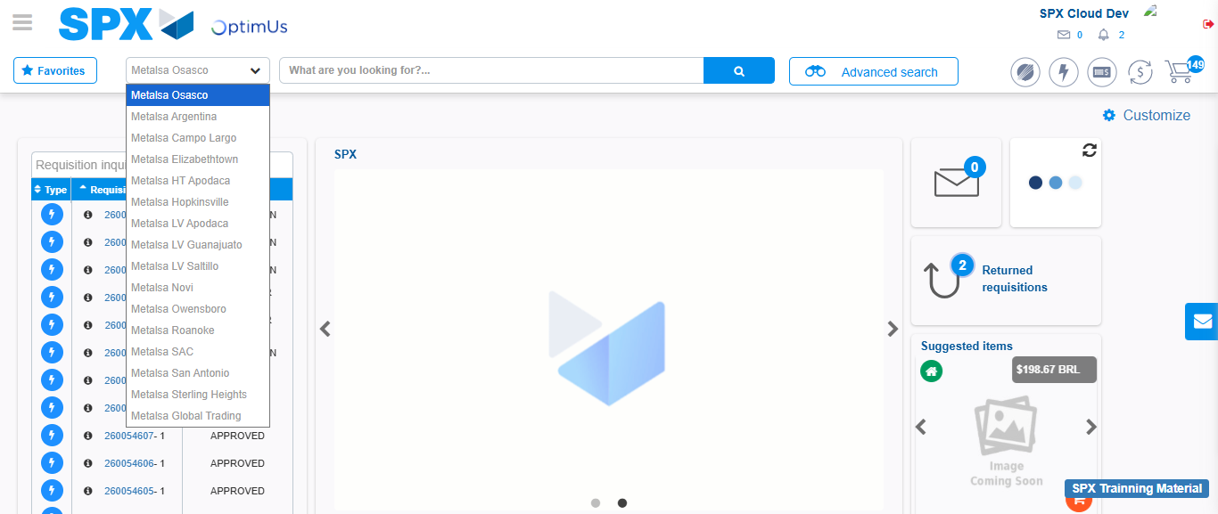Image file-name: QC_Testing-tc001_SPX_Dev5_Crear_Requisicion_Spot_Tipo_Cobro_CC-1783980181676

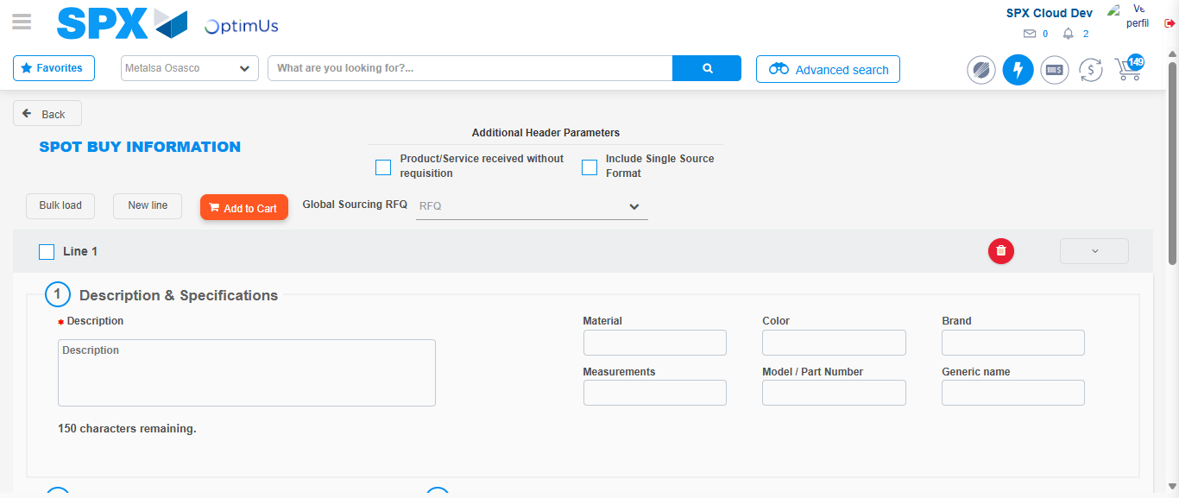Image file-name: QC_Testing-tc001_SPX_Dev5_Crear_Requisicion_Spot_Tipo_Cobro_CC-1783980203880

Step 3 - Data Capture Spot Buy Requisition : Data captured correctly
Image file-name: QC_Testing-tc001_SPX_Dev5_Crear_Requisicion_Spot_Tipo_Cobro_CC-1783980204133

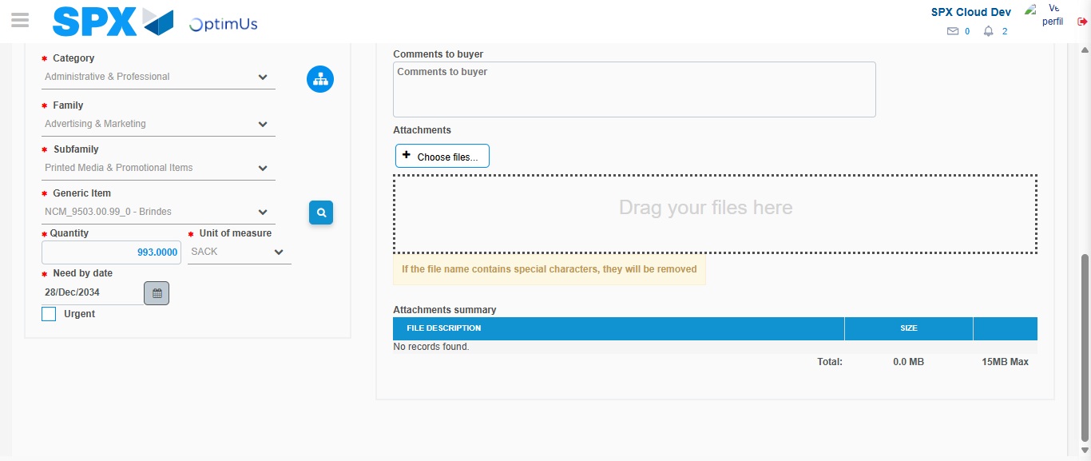Image file-name: QC_Testing-tc001_SPX_Dev5_Crear_Requisicion_Spot_Tipo_Cobro_CC-1783980215298

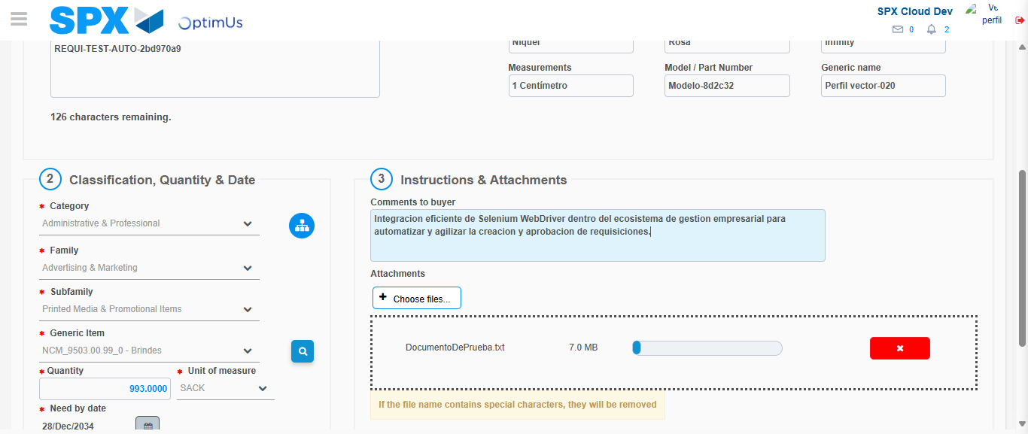Image file-name: QC_Testing-tc001_SPX_Dev5_Crear_Requisicion_Spot_Tipo_Cobro_CC-1783980216028

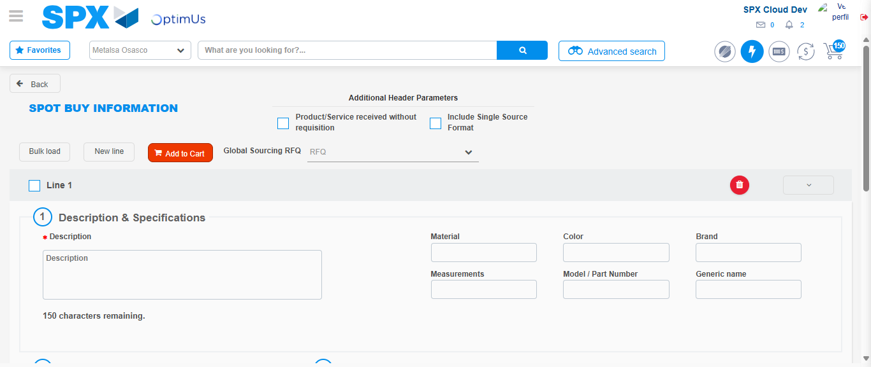Image file-name: QC_Testing-tc001_SPX_Dev5_Crear_Requisicion_Spot_Tipo_Cobro_CC-1783980226982

Step 7 - Return to Main Page SPX : Return to Main Page SPX
Image file-name: QC_Testing-tc001_SPX_Dev5_Crear_Requisicion_Spot_Tipo_Cobro_CC-1783980179077

Image file-name: QC_Testing-tc001_SPX_Dev5_Crear_Requisicion_Spot_Tipo_Cobro_CC-1783980181676

Image file-name: QC_Testing-tc001_SPX_Dev5_Crear_Requisicion_Spot_Tipo_Cobro_CC-1783980203880

Image file-name: QC_Testing-tc001_SPX_Dev5_Crear_Requisicion_Spot_Tipo_Cobro_CC-1783980229188

Image file-name: QC_Testing-tc001_SPX_Dev5_Crear_Requisicion_Spot_Tipo_Cobro_CC-1783980229388

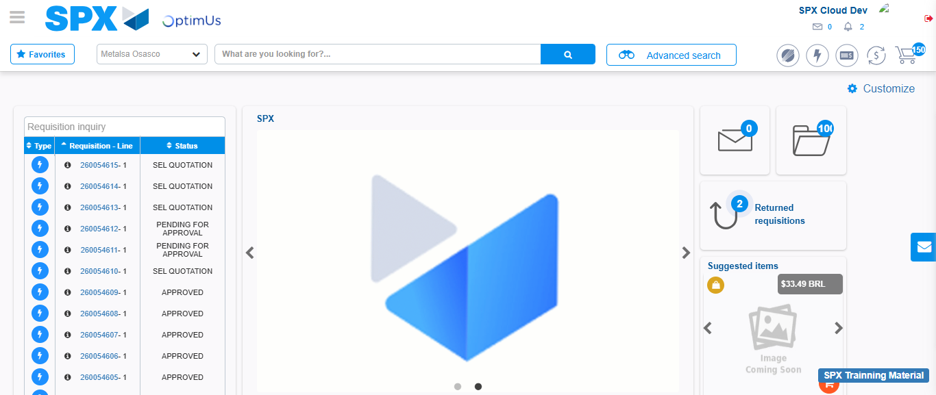Image file-name: QC_Testing-tc001_SPX_Dev5_Crear_Requisicion_Spot_Tipo_Cobro_CC-1783980250416

Step 8 - Log Out : Log Out SPX
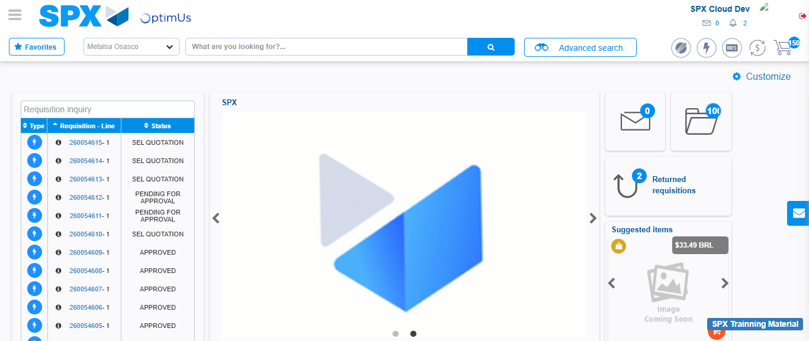Image file-name: QC_Testing-tc001_SPX_Dev5_Crear_Requisicion_Spot_Tipo_Cobro_CC-1783980250708

